**Ideation Phase**

**Empathize & Discover**

|  |  |
| --- | --- |
| Date | 29 September 2022 |
| Team ID | PNT2022TMID37002 |
| Project Name | IOT – SMART FARMING |
| Maximum Marks | 4 Mark |

***EMPATHY MAP:***

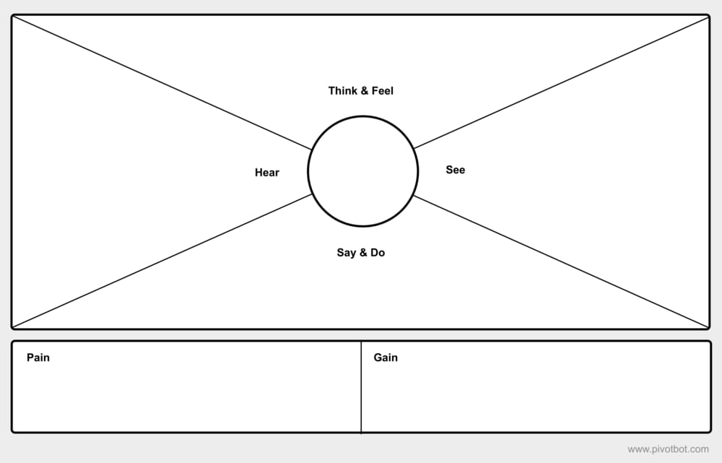

*Refreshing oxygen *good harvest *new learning *more productive

*A lot of effort * time consuming *confused *little space

***Exchange his knowledge***

Future plans

*Information about gardening*

***Construct with structure plants***

Not sure about soil condition

I’m very much into experimenting

Place for experiment

Can see the visible growth

comfortable

Loves gardening

Being relaxed